EGLHE-EQUINE-GUIDED LEARNING EXPERIENCE
  - PRELIMINARY QUESTIONS
TWO HAWKS RANCH, LARKSPUR, co

EQUINE GUIDE: JIMMY

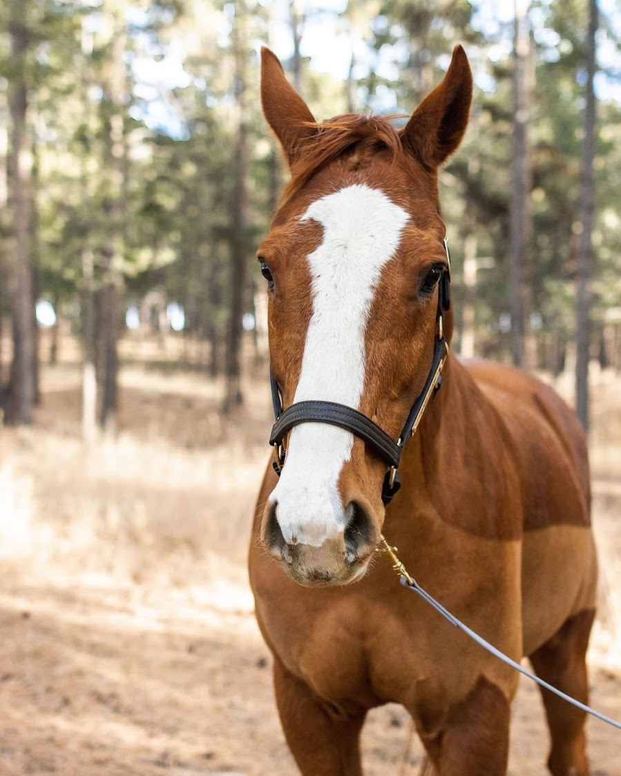

OFF-THE-TRACK THOROUGHBRED HORSE born in 2010

Your name: __________________________________

please be sure to sign these two waivers:
- Ranch release: https://two-hawks-ranch.com/release.html
- EGLHE release: EGLHE liability release (email or bring a copy)

QUESTION 1)
What is your experience with nonhuman animals? Do you feel comfortable interacting with other species?

QUESTION 2)
Do you directly care for any nonhuman animals at the moment? If yes, which species? How many? How would you describe the care?

QUESTION 3)
Do you sometimes feel the need to be around nonhuman animals? Could you explain why?

QUESTION 3)
Do you have any previous experience with equines? If yes: what kind? For how long? Please, give as many details as possible

QUESTION 4)
How do you think this EGLHE relates to your current class? What would you wish to gain from this EGLHE?

Any more comments, questions, requests?

instructions:
The EGLHE usually happens outside.
- Consider the weather and the rural setting when selecting clothes. Layers are usually a good choice. Wear boots with a strong toe and some grip. Long sleeves, sun glasses, and sun block are advisable (in winter too, because of the glare from the snow).
- Be ready to enjoy some horse hair, dust and mud on your clothes and boots :)
- Be prepared to be relaxed while aware of your surroundings. Please, for everyone's safety, follow my instructions closely when you will be around horses. Keep a safe distance and come near when asked.
- Read page 32-37 of Unhobbled by Christiane Wirt (from "I am about to adopt a wild Mustang" to "I counter"): UNHOBBLED
Thank you and have fun!

