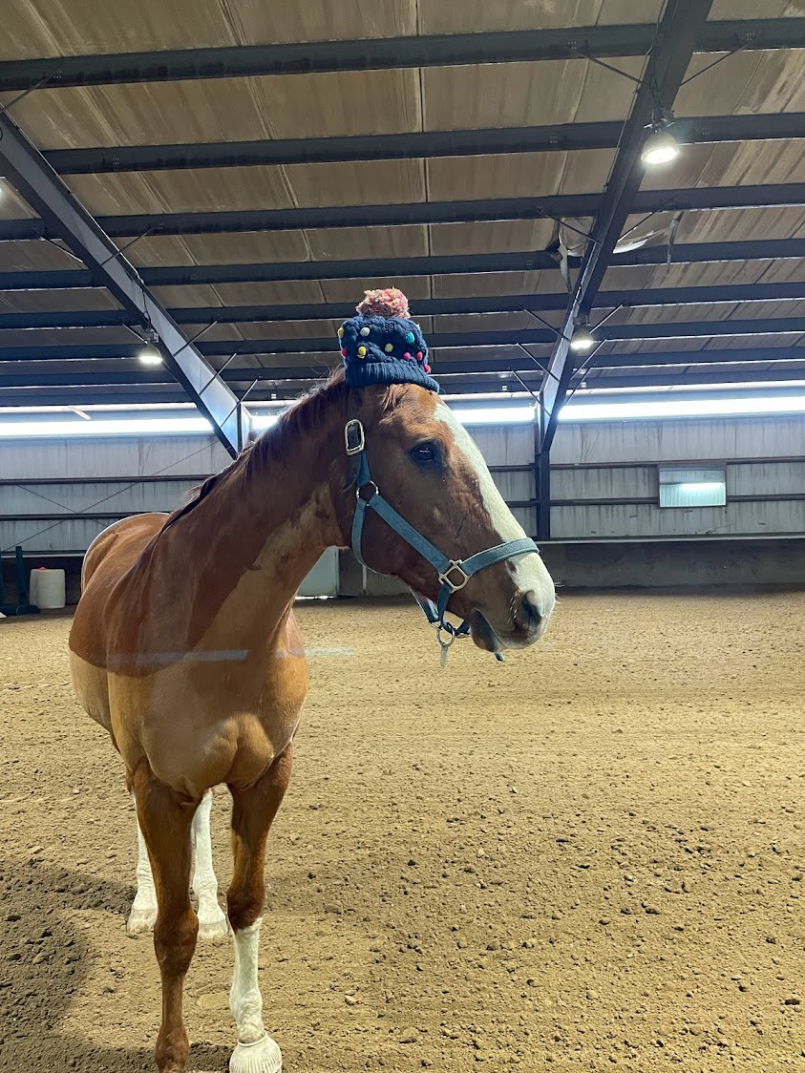
(Jimmy likes to borrow my hat sometimes!)

Post-EGLHE Reflection
Today, with Jimmy's help, we spent about an hour discussing some basic concepts of attuned horsemanship (attunement, connection, self-awareness). We also discussed how reflecting mindfully on the interaction with other sentient beings may relate to the course you are taking.

1) How would you compare your mood and state of mind when you arrived to the ranch to when you left? And that evening once you were back to your dorm/house?

2) Which moment of your interaction with Jimmy was more interesting, important, pleasant? Could you explain how/why?

3) Do you feel like you learned something new today? Did this experience inspire other kinds of reflections on your schoolwork and life in general?

4) Was there anything missing that you would have liked to experience?

5) Is this an experience you would recommend to other students?

6) EGLHE is structured over various steps: today you saw the very first one. Would you be interested in EGLHE n.2? (In EGLHE n.2 you would spend more time connecting with your equine guide, and if all the preliminary steps go well, the equine would lead you on a walk around the ranch (groundwork)

7) Any other comments, ideas, suggestions?

Thank you! :)

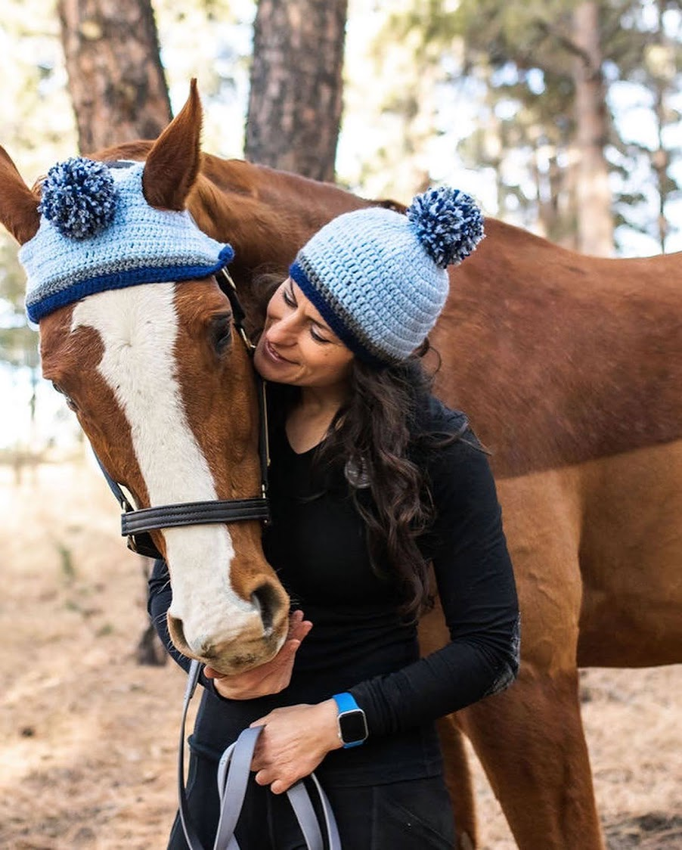
(so I bought us matching hats!)

